**Q1:**

1. Relative Cell Referencing in Excel:

A Relative cell reference changes when copying or moving the formula or cell value to a different location in the worksheet. Relative references are very useful when you have a range of cells and you want the references to relatively change as and when you copy the formula down to other cells.

Let us understand this with a small example.

Below is an image that displays the three different tables. The first contains the original Data, the second contains a Result that appears using the formula (i.e. cell referencing), and the third table portrays the formula that we used (i.e. the cell addresses).

1. In the cell G5 below we try to link it with C5

2. It gives the same value that is present in cell C5 i.e. the number 5

3. When you copy the link from G5 TO H6, the reference shall relatively change from C5 TO D6

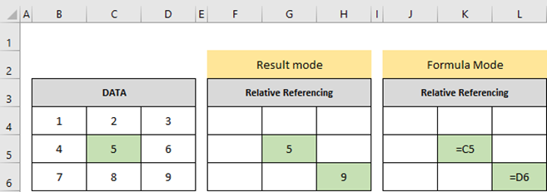

2. Absolute Cell Referencing in Excel:

An absolute cell reference does not change while copying or moving the formula to a different location in the worksheet. The cell references are fixed. Now you would wonder how can you fix cell reference?

To fix the cell references, we need to add a Dollar sign ($) before the column name and the row number by pressing the key F4. The F4 Key will allow you to add a dollar sign automatically before the cell references.

Let us understand this with an example.

1. In the below image, in cell G5, we link cell C5. But we want to fix the cell reference so that it does not change when copying the formula to other cells. To fix the cells press the key F4, which will insert a dollar symbol before the column name and row number
2. . It returns the same value as in cell C5. Now when you copy the formula from G5 to H5, it still returns the same value as in C5, since the reference is now fixed and shall not change when copying the formula

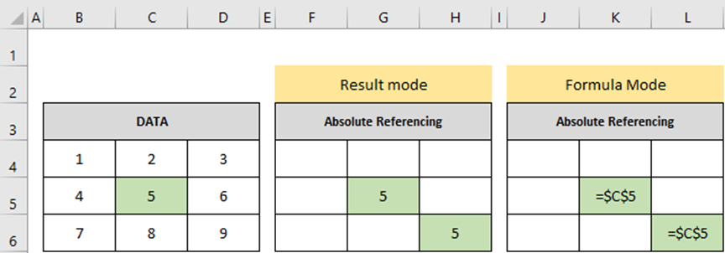

**Q2: How to secure**

1. Click Review > Protect Workbook.

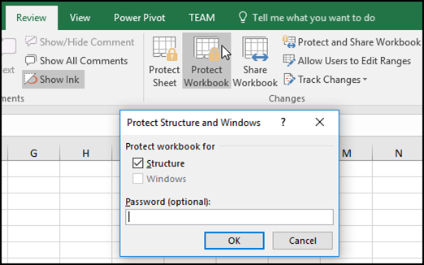

Note: The Windows option is available only in Excel 2007, Excel 2010, Excel for Mac 2011, and Excel 2016 for Mac. Select the Windows option if you want to prevent users from moving, resizing, or closing the workbook window, or hide/unhide windows.

1. Enter a password in the Password box.

Important: The password is optional. If you do not supply a password, any user can unprotect and change the workbook. If you do enter a password, make sure that you choose a password that is easy to remember. Write your passwords down and store them someplace safe. If you lose them, Excel cannot recover them for you.

1. Select OK, re-enter the password to confirm it, and then select OK again.

**Q3: Pivot table**

A [Pivot Table](https://en.wikipedia.org/wiki/Pivot_table) is one of the basic data analysis tools. Pivot Tables can quickly answer many important business questions.

One of the reasons we build Pivot Tables is to pass information. We would like to support our story with data that is easy to understand, easy to see.

Although Pivot Tables are only tables and thus missing real visuals, they can still be considered as a mean of [Visual Storytelling](https://www.visualstorytell.com/blog/what-is-visual-storytelling).

|  |  |  |  |  |  |  |  |  |  |  |  |  |
| --- | --- | --- | --- | --- | --- | --- | --- | --- | --- | --- | --- | --- |
| **Pivot Table** |  |  |  |  |  |  |  |  |  |  |  |  |
| **Count of Sales** | **Column Labels** |  |  |  |  |  |  |  |  |  |  |  |
| **Row Labels** | **Store 1** | **Store 10** | **Store 2** | **Store 3** | **Store 4** | **Store 5** | **Store 6** | **Store 7** | **Store 8** | **Store 9** | **(blank)** | **Grand Total** |
| <1/1/2016 or (blank) | 1713 | 1814 | 1752 | 1698 | 1649 | 1736 | 1793 | 1736 | 1801 | 1793 |  | 17485 |
| Jan | 681 | 619 | 642 | 663 | 654 | 665 | 664 | 625 | 628 | 662 |  | 6503 |
| Feb | 833 | 843 | 835 | 837 | 841 | 807 | 800 | 798 | 794 | 804 |  | 8192 |
| Mar | 1010 | 1120 | 1010 | 1055 | 1112 | 1057 | 991 | 1073 | 1064 | 1026 |  | 10518 |
| Apr | 1157 | 1200 | 1137 | 1173 | 1120 | 1092 | 1189 | 1126 | 1240 | 1147 |  | 11581 |
| May | 1406 | 1382 | 1408 | 1407 | 1440 | 1440 | 1273 | 1463 | 1427 | 1421 |  | 14067 |
| Jun | 1602 | 1541 | 1602 | 1549 | 1518 | 1536 | 1564 | 1618 | 1488 | 1521 |  | 15539 |
| Jul | 1813 | 1771 | 1718 | 1844 | 1725 | 1792 | 1811 | 1705 | 1759 | 1767 |  | 17705 |
| Aug | 1861 | 1824 | 1767 | 1819 | 1813 | 1817 | 1806 | 1794 | 1841 | 1743 |  | 18085 |
| Sep | 1448 | 1478 | 1457 | 1475 | 1501 | 1443 | 1455 | 1499 | 1451 | 1444 |  | 14651 |
| Oct | 930 | 999 | 1012 | 952 | 935 | 912 | 951 | 923 | 951 | 950 |  | 9515 |
| Nov | 422 | 437 | 426 | 396 | 410 | 404 | 417 | 393 | 415 | 432 |  | 4152 |
| Dec | 150 | 156 | 183 | 161 | 134 | 144 | 149 | 157 | 156 | 153 |  | 1543 |
| >1/1/2017 | 51 | 51 | 47 | 39 | 47 | 43 | 49 | 43 | 48 | 45 |  | 463 |
| **Grand Total** | **15077** | **15235** | **14996** | **15068** | **14899** | **14888** | **14912** | **14953** | **15063** | **14908** |  | **149999** |

**Q4: Lookup function**

Use LOOKUP, one of the [lookup and reference functions](https://support.microsoft.com/en-us/office/excel-functions-by-category-5f91f4e9-7b42-46d2-9bd1-63f26a86c0eb#__toc309306714), when you need to look in a single row or column and find a value from the same position in a second row or column.

|  |  |  |  |
| --- | --- | --- | --- |
| **VLookup** |  |  |  |
| **Number** | **Description** | **Type** | **Price in INR** |
| 1 | Apple | Mobile | 90000 |
| 2 | Motorola | Mobile | 14000 |
| 3 | One Plus | Mobile | 35000 |
| 4 | Asus | Mobile | 35000 |
| 5 | Razer | Mobile | 90000 |
| 6 | Microsoft | Laptop | 95000 |
| 7 | Apple | Laptop | 125000 |
| 8 | LG | Mobile | 15000 |
| 9 | Kodak | Camera | 60000 |
| 10 | Canon | Camera | 70000 |
|  |  |  |  |
|  |  |  |  |

|  |  |
| --- | --- |
| VLOOKUP |  |
| Razer | 90000 |
| Kodak | 60000 |
| One Plus | 35000 |
|  |  |
|  |  |
|  |  |
|  |  |
| HLOOKUP |  |
| Razer | 90000 |
| Kodak | 60000 |
| One Plus | 35000 |

**Q5: Data validation**

Excel data validation is a feature that allows you to control the type of data entered into your worksheet. For example, Excel data validation allows you to limit data entries to a selection from a dropdown list and to restrict certain data entries, such as dates or numbers outside of a predetermined range. Data validation can also help you control formulas and the input from those formulas. You can even craft custom Excel data validation messages that help guide users toward the right data entry when they hit a limit. As a result, Excel data validation helps reduce the amount of unstandardized data, errors, or irrelevant information in your worksheet.

|  |  |  |
| --- | --- | --- |
| Data validation | | |
| List | Whole Number <100 | Date |
| Low | 56 | 7/1/2022 |
| Medium | 95 | 5/15/2022 |
| Medium | 100 | 6/30/2022 |
| High |  |  |
| High |  |  |